**Rapid Search Engine – Project Plan**

1. **Introduction**
   1. **Document Purpose**

Gather all information necessary to plan the project. It describes the approach to the development of the software and is a top-level plan.

* 1. **Development Approach**

The system will be built in a Top Down view, while Logic part leads.

1. **Project Overview**
   1. **Project Purpose**
   2. **Assumptions and Constraints**
      1. Programming language: Python, SQL.
      2. Main efforts: scrape HTML code, presenting search results quickly.
      3. Constraints: development time is limited due to studying in the background.
   3. **Project Deliverables**
2. **Project Gantt Chart**

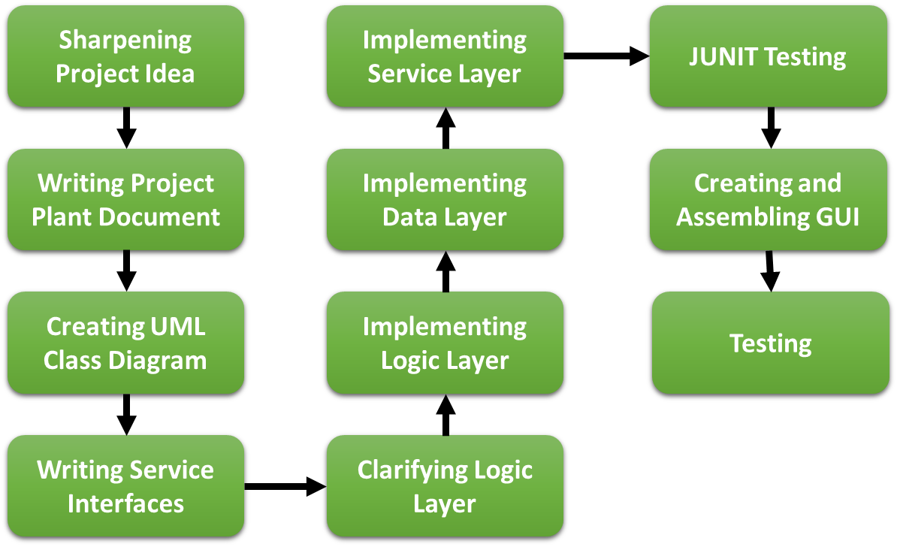

1. **UML Class Diagram**